Title: **Midterm** Test: Midterm

Course: Intro to Automation Unit: Manual Motor Control CLO: 1

Name ______________________________ Grade ________ Date ________________

**Objectives**

1. Student shall identify the NEMA symbols and whether they are an input or an output.
2. Student shall recall the components of a ladder diagram.
3. Student shall list items found on a single or three-phase motor nameplate.
4. Student shall calculate the acceptable input voltage range given the motors rated voltage.
5. Student shall identify how to reverse a single-phase and three-phase AC motors.

**Assessment**

Students shall demonstrate a comprehension of the objectives listed above by scoring a minimum of 75% on this Test. Grading shall be based on the answer key.

**Instructions**

Label each NEMA symbol with the appropriate description and identify whether the symbol is an input or an output.

|  | Symbol | Description | Input/Output |
| --- | --- | --- | --- |
|  |  |  |  |
|  |  |  |  |
|  |  |  |  |
|  |  |  |  |
|  |  |  |  |
|  |  |  |  |
|  |  |  |  |

|  | Symbol | Description | Input/Output |
| --- | --- | --- | --- |
|  |  |  |  |
|  |  |  |  |
|  |  |  |  |
|  |  |  |  |
|  |  |  |  |
|  |  |  |  |
|  |  |  |  |
|  |  |  |  |
|  |  |  |  |
|  |  |  |  |
|  |  |  |  |

**Instructions**

Answer each of the individual questions below.

1. When building a control circuit, there is not an industry standard for the order of the components on the rung.
   1. True
   2. False
2. If a circuit has three discrete inputs, how many possible states can that circuit be placed?

____

1. When hand drawing a control schematic, wire numbers are denoted by using?
2. Boxes
3. Triangles
4. Circles
5. Underline
6. When hand drawing a control schematic, cross-reference numbers are placed?
7. In boxes
8. To the left of the ladder rail
9. In the middle of the line
10. To the right of the ladder rail
11. Draw a truth table for the above circuit.
12. How would you describe this circuit?
13. EQUAL Logic
14. NOT Logic
15. AND Logic
16. OR Logic
17. When designing a control schematic, input devices (pushbuttons, selector switches) should be labelled by?
18. The type of device they are.
19. The action that they will perform
20. The type of contacts that they use
21. All the above
22. An eight-pin relay, like the one we use in class, may also be labelled as a?
23. STST Relay
24. DPDT Relay
25. SPDT Relay
26. DPST Relay
27. The follow graphic is what type of ANSI symbol.
28. Form A Contact
29. Form B Contact
30. Form C Contact
31. Form D Contact
32. Match the schematic symbols to the components of a relay.

|  |  |  |  |  |
| --- | --- | --- | --- | --- |
|  | |  | | --- | |  | |  | |  | |

Identify each component of an AC single-phase induction motor.

1. 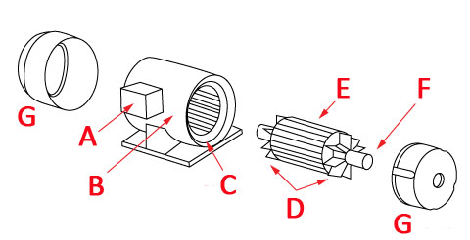End Bell _____
2. Stator _____
3. Rotor _____
4. Terminal Box _____
5. Motor Frame _____
6. Fans _____
7. Shaft _____
8. What is the term used in the field to describe a single-phase AC induction motor that we are using in class?
9. Rat cage
10. Hamster wheel
11. Squirrel cage
12. Ferret trap
13. What is the field term for the terminal box on the side of a motor?
14. Dim-head
15. Pecker-head
16. Knock box
17. Hot box
18. Select the alternate term used to describe the normal state of a component.
19. Open
20. Made
21. Shelf
22. Switched
23. Select the correct term used to describe the state of a component that is conducting current.
24. Open
25. Made
26. Shelf
27. Switched

Answer each of the individual questions below.

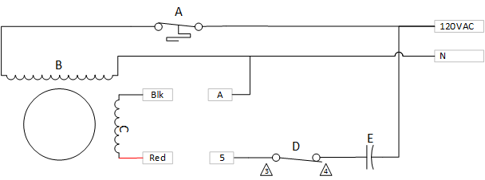

1. Match the components in the above single-phase motor schematic to their components.
   1. ______________ Run Windings
   2. ______________ Capacitor
   3. ______________ Thermal Switch
   4. ______________ Start Switch
   5. ______________ Start Windings
2. If the motor is running CCW with Blk wired to A and Red wired to 5, how should the motor be re-wired to obtain a CW rotation?
3. Explain why re-wiring this winding causes the motor to rotate in the opposite direction?
   1. A switch inside the motor is changed
   2. AC is flowing in the other direction
   3. The poles of the start windings are reversed
   4. The capacitor is reversed in the circuit
4. A single-phase motor cannot change its rotation while running at full speed.
   1. True
   2. False
5. An AC induction motor has a permanent magnet that creates the magnetic field.
   1. True
   2. False

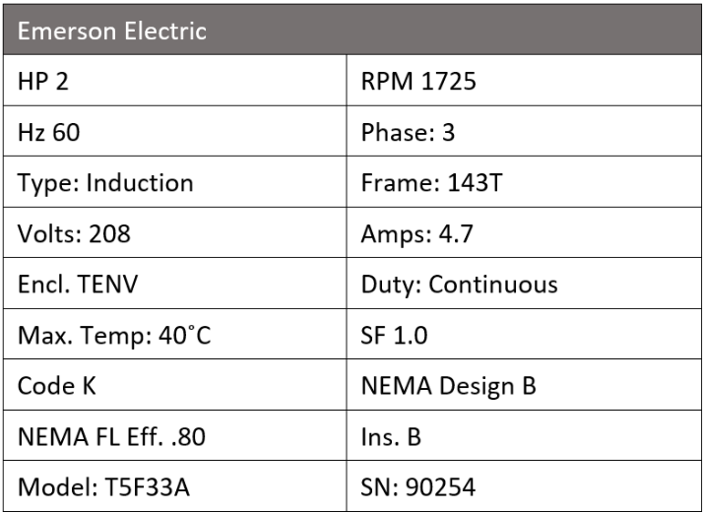Answer each of the individual questions below.

1. What is the horsepower for this motor? __________
2. How many watts should this motor dissipate? _________
3. What nominal voltage source would you use to connect to this motor? ___________
4. What is the acceptable range of voltage input to this motor? _______ to _______
5. Which value on the nameplate indicates how the motor will cool itself?
   1. Duty
   2. SF
   3. Max. Temp.
   4. Encl.
6. The value on the nameplate indicating the appropriate ambient temperature for which this motor is rated?
7. Duty
8. SF
9. Max. Temp.
10. Encl.
11. This motor is suitable to be used in an industrial setting?
12. True
13. False
14. This motor can be loaded to more than its rated horsepower for short periods of time.
15. True
16. False
17. If this motor was installed in the U.S., it would spin faster than its rated RPM.
18. True
19. False
20. What determines the RPM value that is stamped on the nameplate?
21. The number of poles
22. Slip
23. Input frequency
24. All the above
25. Residential power is also termed three-phase power?
26. True
27. False
28. What is the most common type of motor found in industry?
29. DC Motor
30. Shunt-wound motor
31. Synchronous motor
32. Induction motor
33. A three-phase motor can change rotation at full speed.
34. True
35. False
36. This motor can run 24/7/365 except for leap-year.
37. True
38. False
39. All these nameplate values are based on the motor performing at;
40. Rated voltage
41. Max. Temp.
42. Full Load
43. Sea Level
44. All the above
45. A motor nameplate is standardized; therefore, all information can be found in the same location on every motor.
46. True
47. False